***GITHUB TASKS:***

***TASK 01:*** *Create A Repository…*

Step 01 : to create new repository click on “***new”***

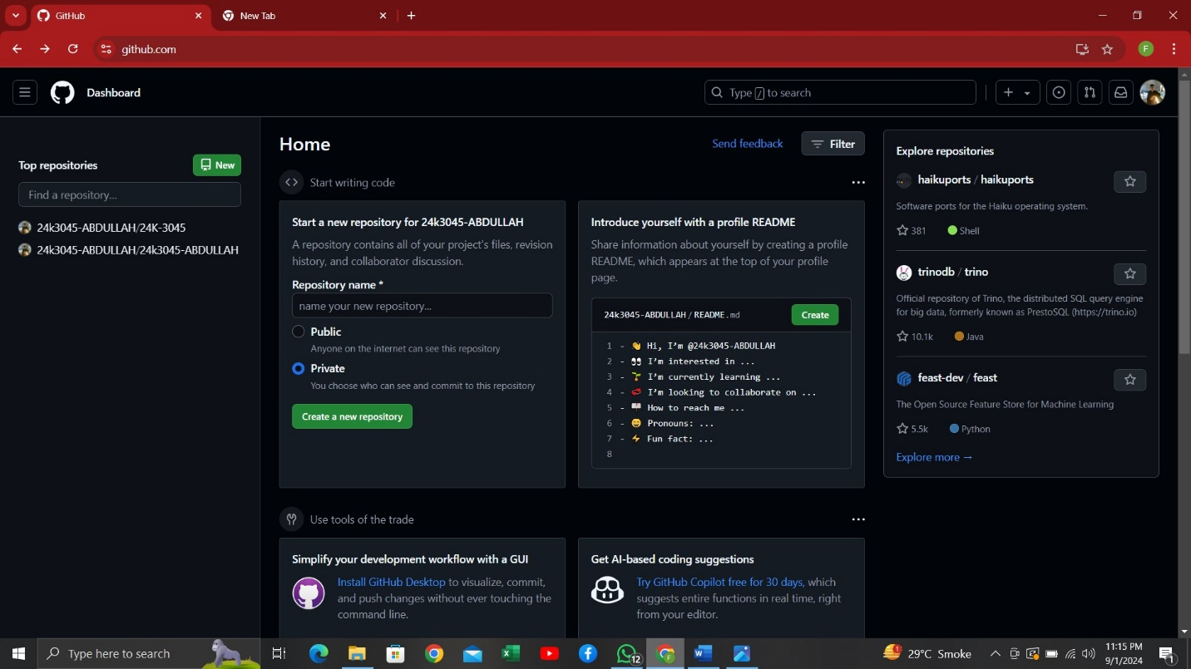

Step 02: ***Change Repo name to be your roll no. (mine is 24k-3045)***

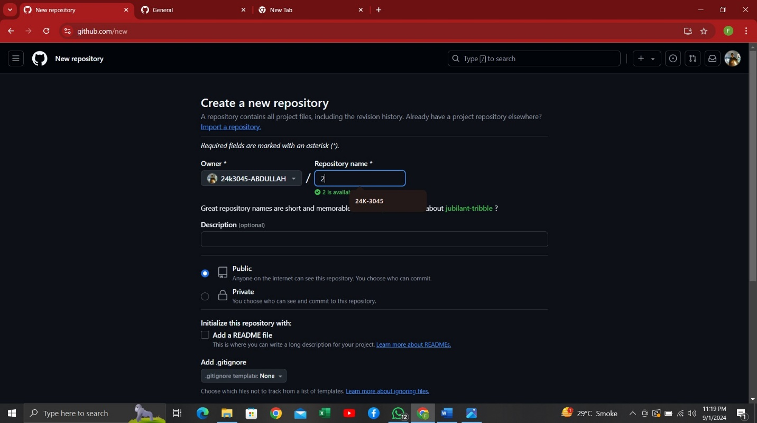

***And you have created new repository***

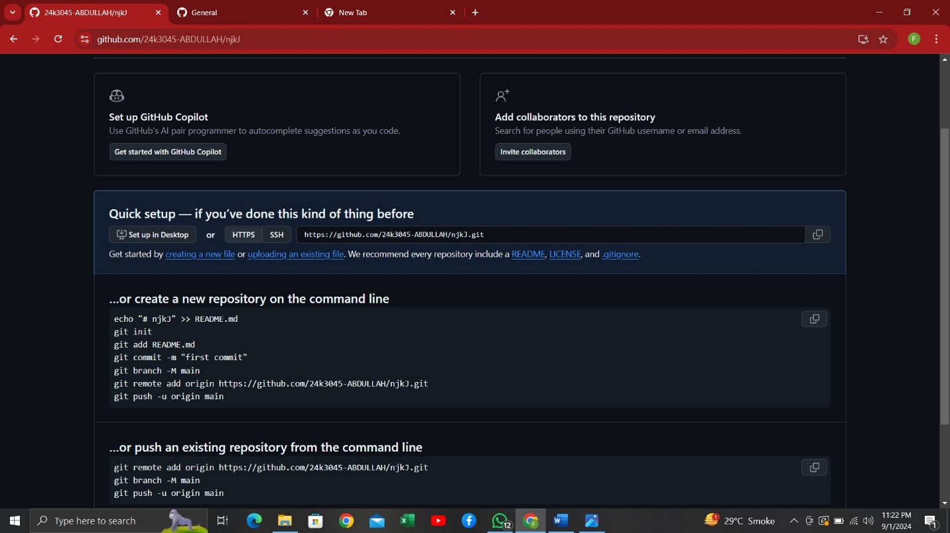

***TASK 02:*** *Upload a file* ***(****PDF****)****…*

*STEP01: select on uploading an existing file*

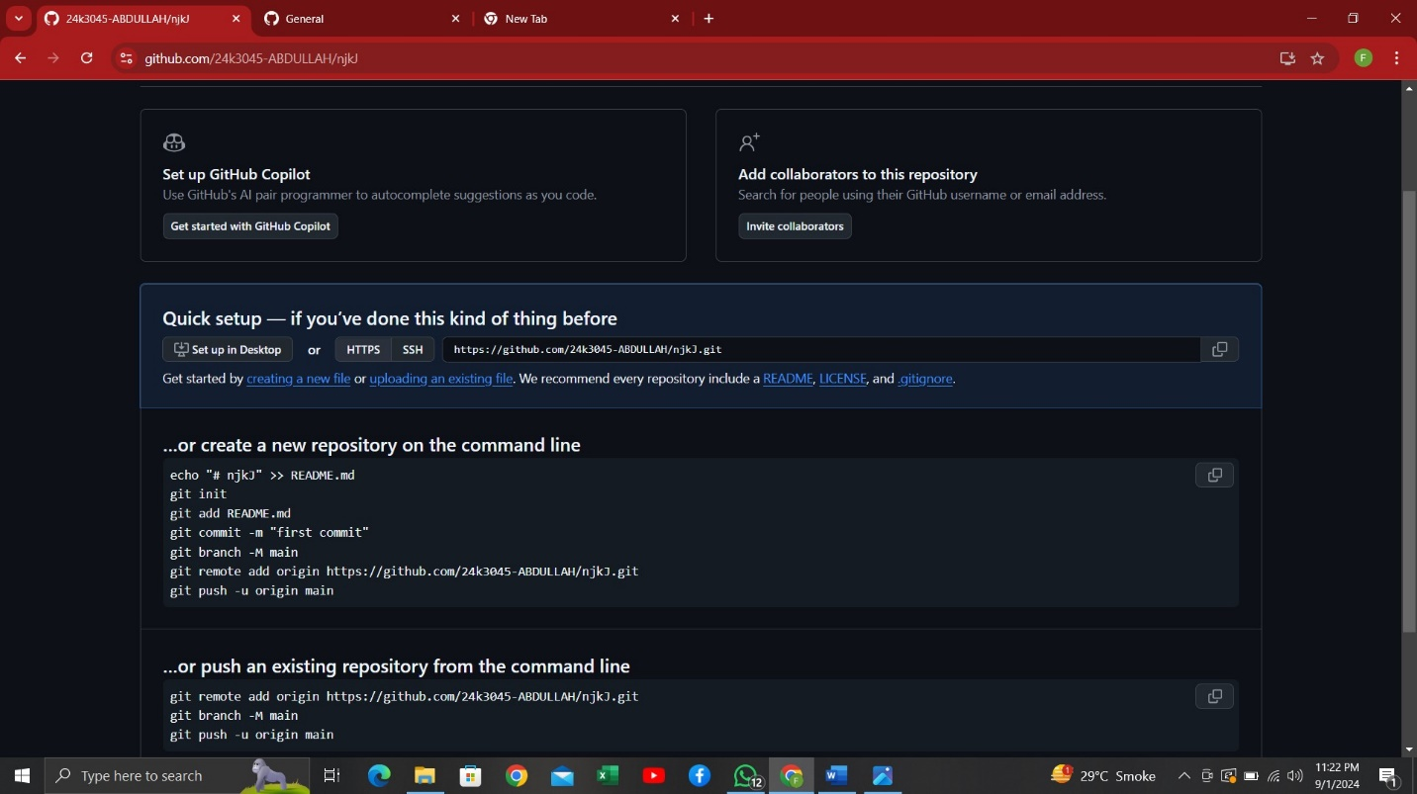

*Step02 : click on “****choose your file****” and upload the file in my CASE (PSEUDOCADES AND ALGORITHM )*

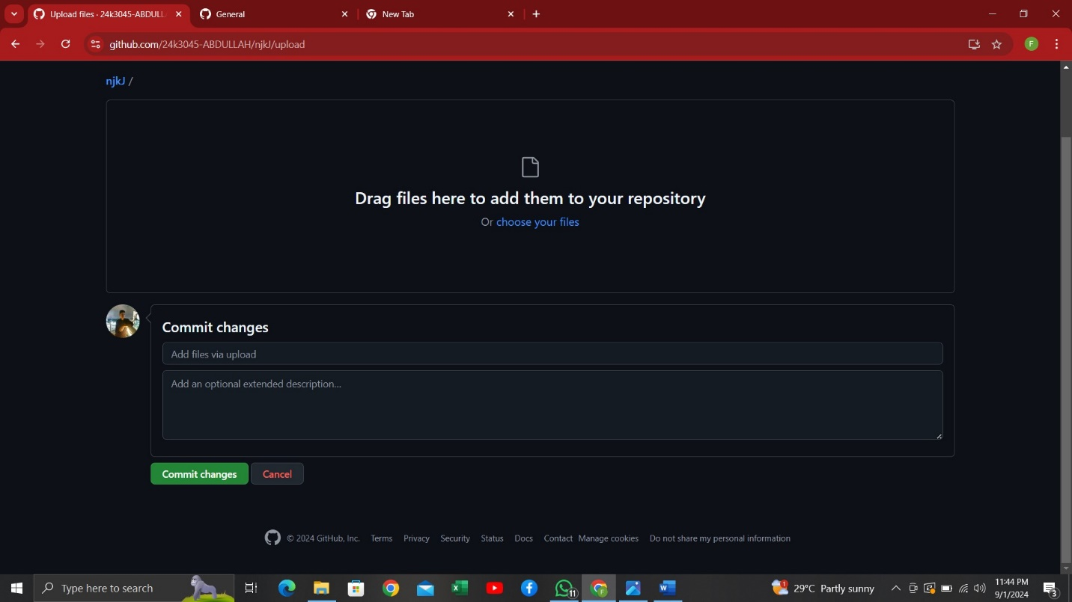

*AND YOU ARE DONE*

*TASK 03 : CREATE INTRO IN README FILE*

*Stepo1 : select pencil option to create intro in readme file*

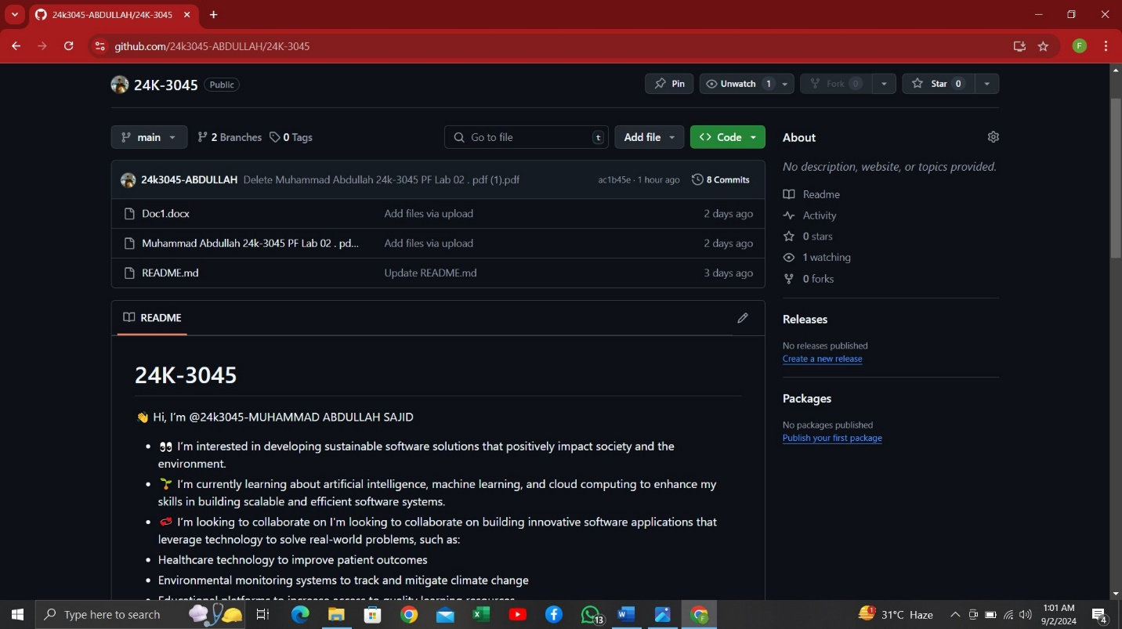

*Step 02 : type your introduction in readme file and upload picture by dragging file from library*

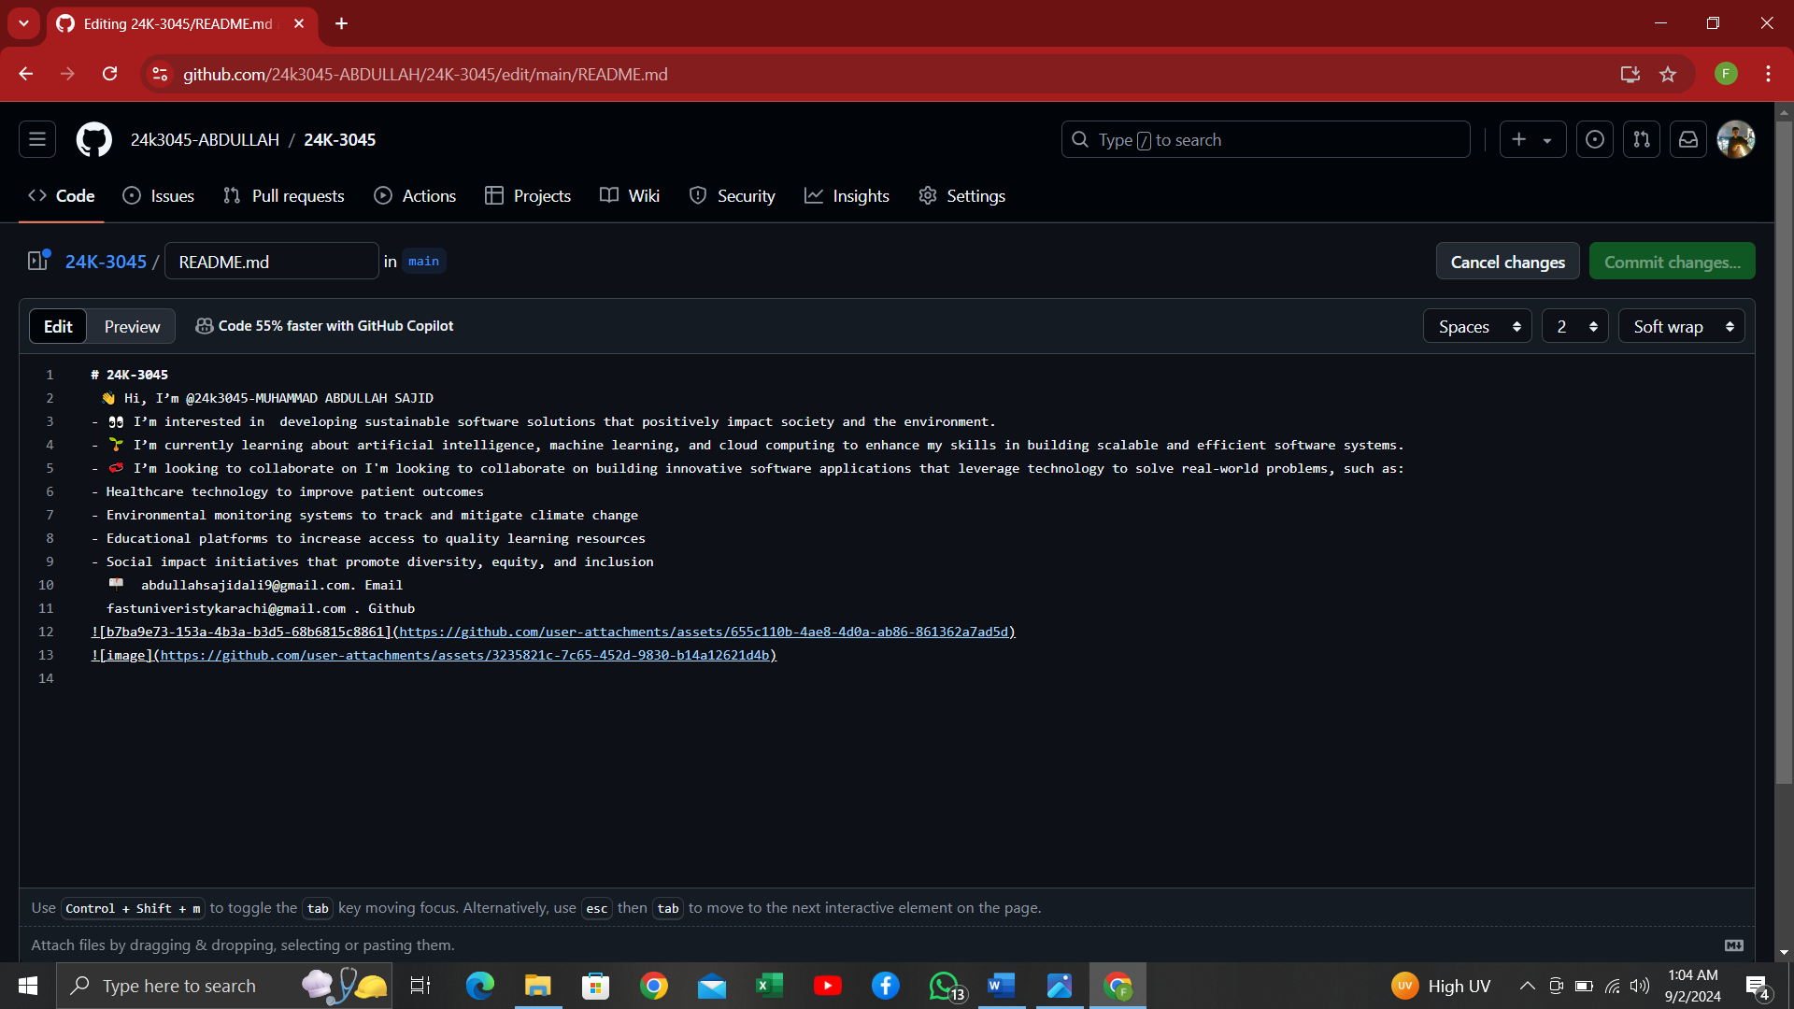

*Step 03 : to save click on commit change and YOU ARE DONE*

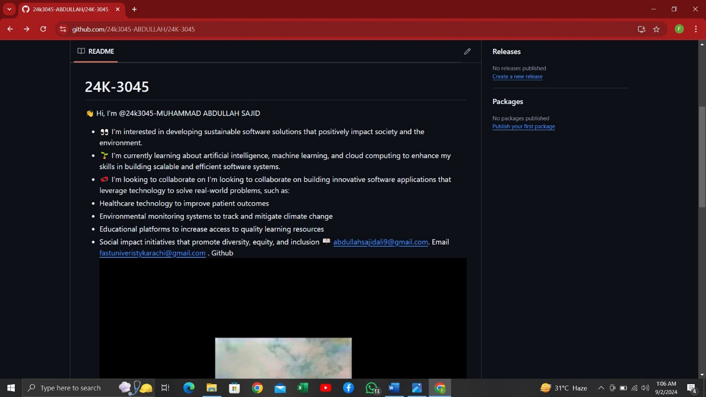

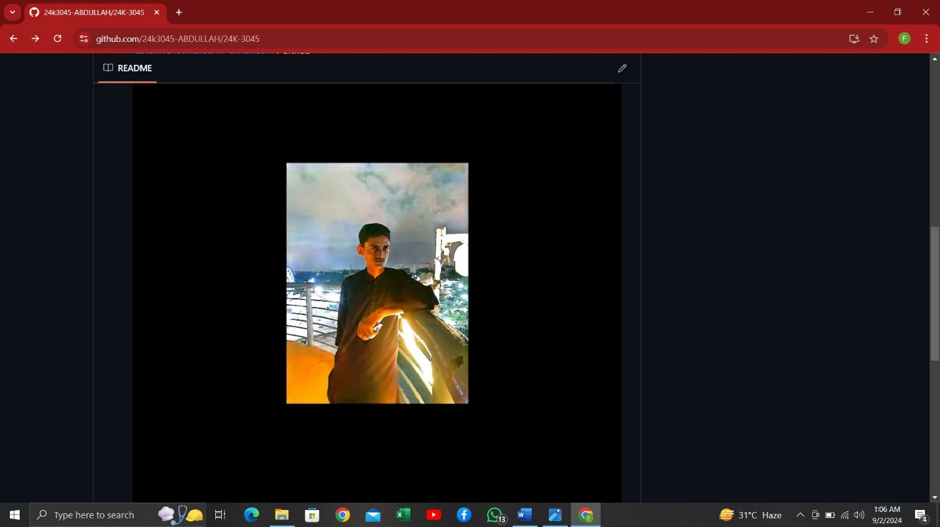

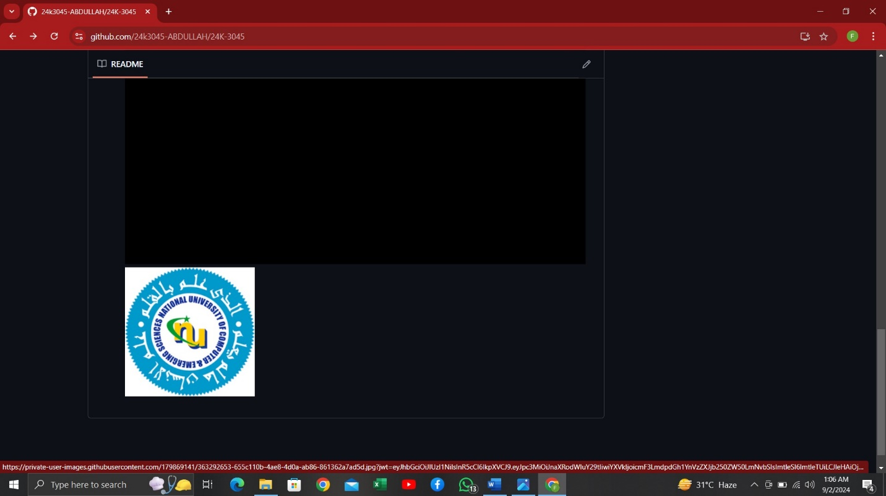

*TASK 04 : create new branch named as “feature” and make changes to readme file*

Step 01: to create new branch click on “***branch***” option

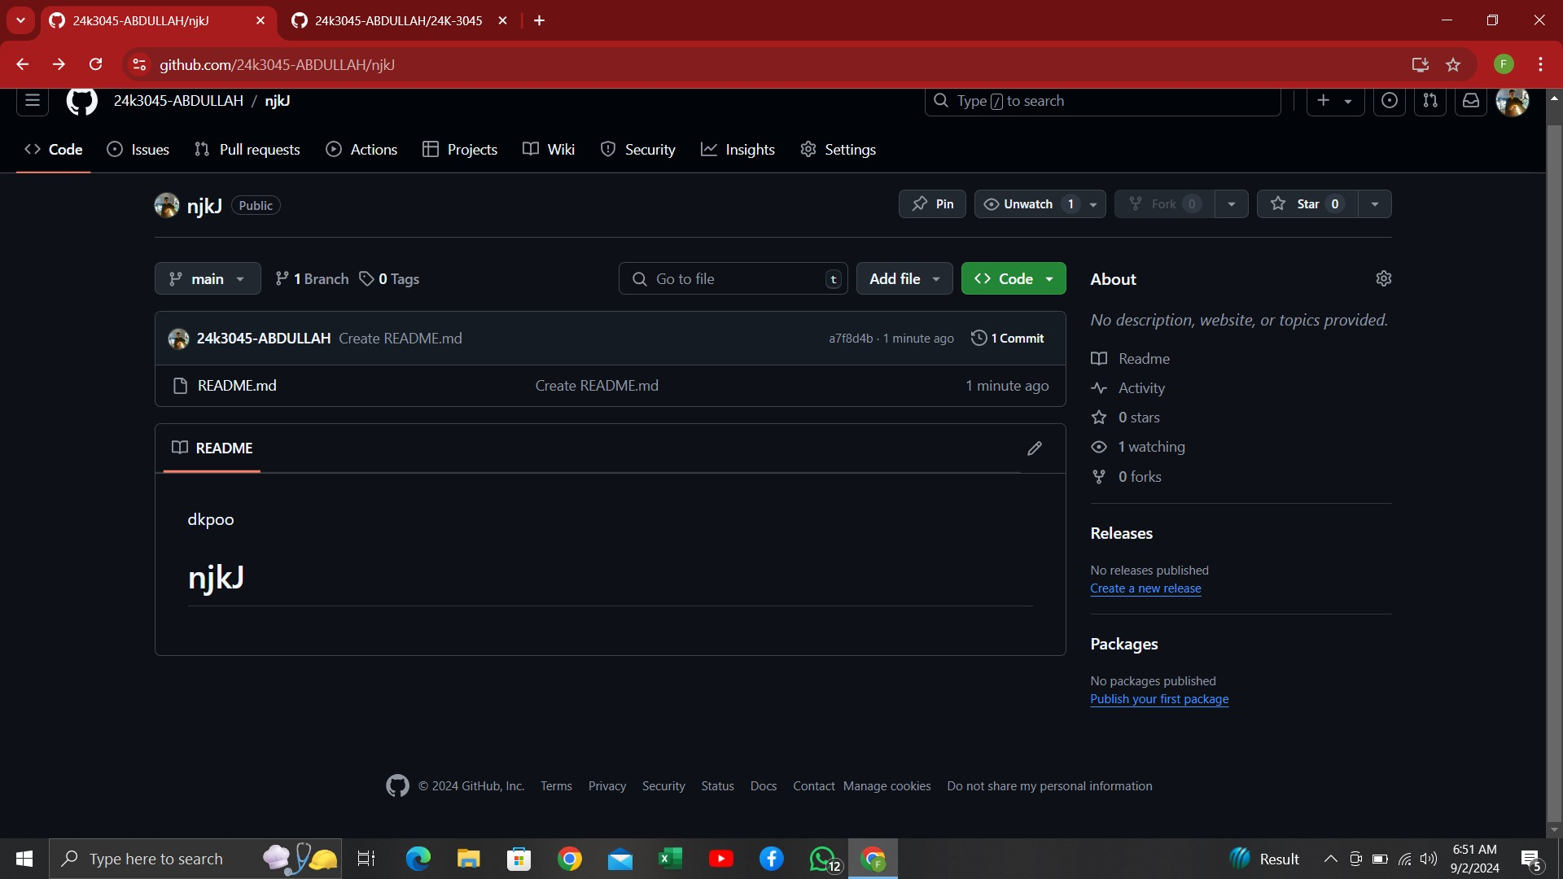

Step 02 : then click on “***new branch”***

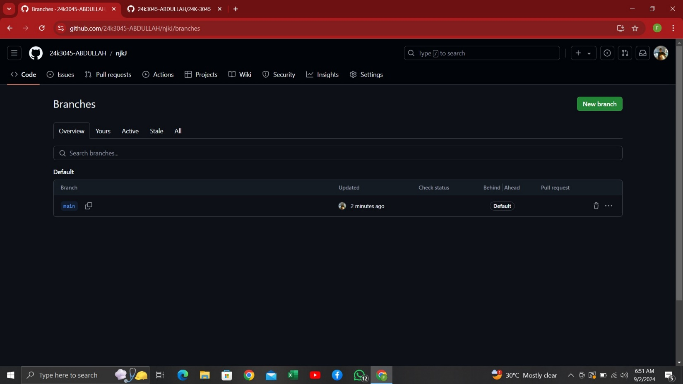

Step 03 : name your branch and then click on ***“create new branch”***

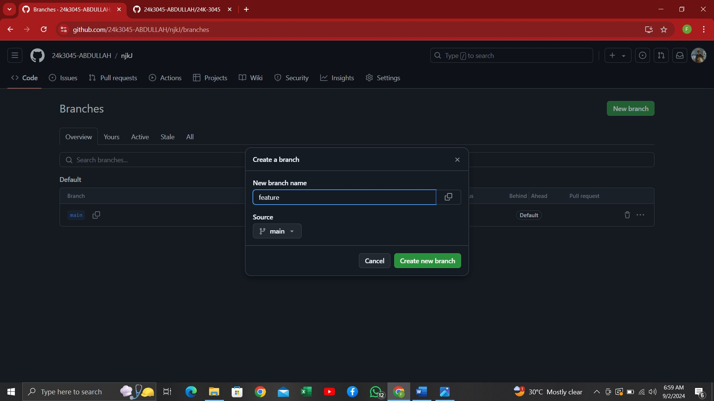

YOUR BRANCH HAS BEEN CREATED SUCESSFULLY

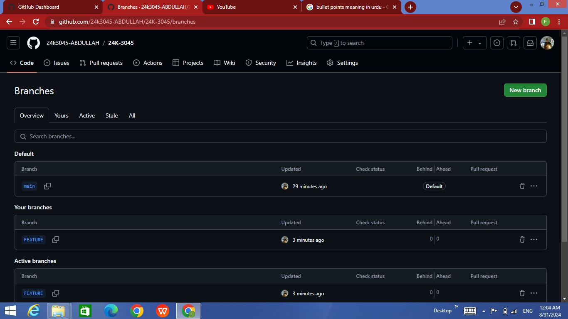

Step 04 : to make changes to readme file open feature branch and click on option of pencil

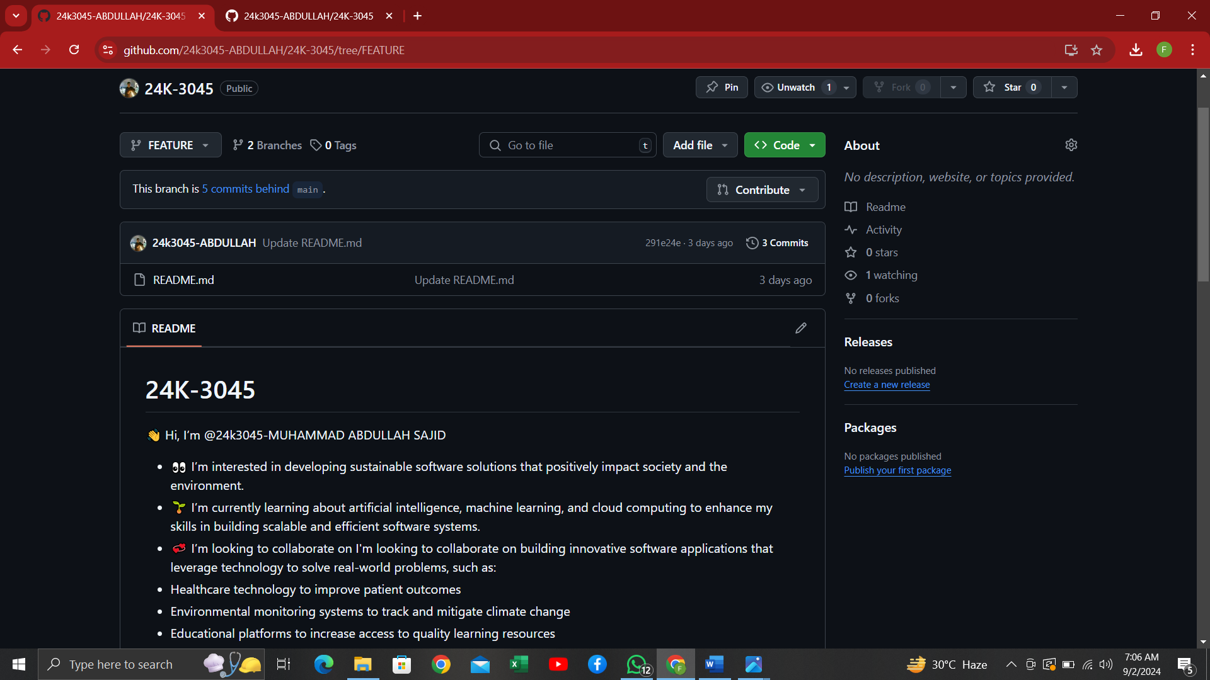



Step 04 : change your readme file by removing your intro and after that select commit changes

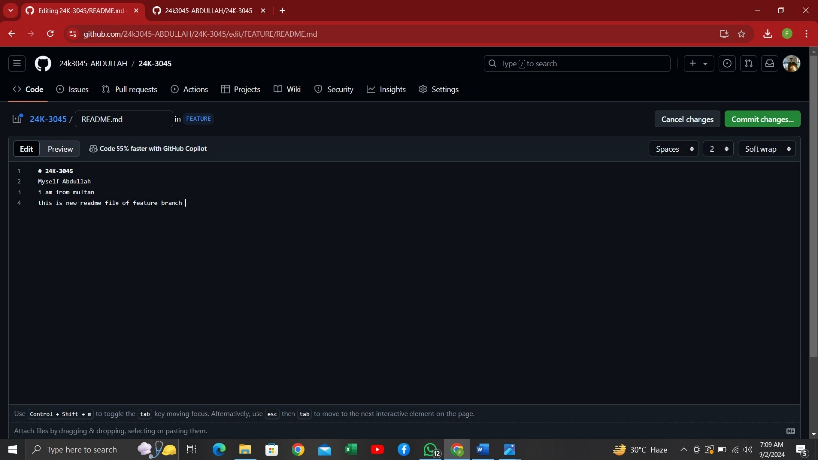

***AND YOU ARE DONE WITH MAKING NEW BRANCH AND CHANGING ITS README FILE-***

